Stephen Laycock  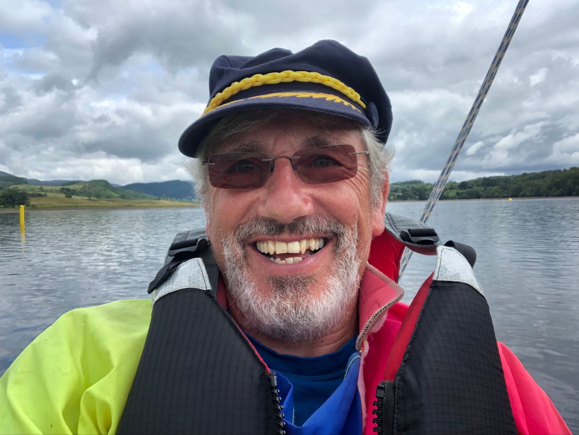  chairman@sailabilityscotland.org.uk  www.sailabilityscotland.org.uk | 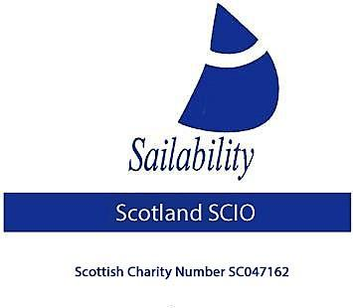
Tack Tick
For 4th August 2022

Gosh what a busy year both as far as both the regattas and the nuts and bolts of the work that goes on behind the scenes!
First and with just two regattas of this year’s series remaining to be contested, let’s take a quick look at how the Traveller series is progressing
 | LVSC | SYC | LESC | CS | CCSC | LSC | Points | Position
D Greenhalgh | 4 | 3 | 1 | 1 |  |  | 9 | 1
R Cameron | 6 | 5 | 3 | 7 |  |  | 21 | 2
A Hodge | 7 | 17(DNC) | 2 | 4 |  |  | 30 | 3
S T Bate | 5 | 17(DNC) | 4 | 5 |  |  | 31 | 4
V Milward | 1 | 1 | 17(DNC) | 17(DNC) |  |  | 36 | 5
D Bennett | 8 | 17(DNC) | 5 | 6 |  |  | 36 | 6
D Driffell | 3 | 2 | 17(DNC) | 17(DNC) |  |  | 39 | 7
N Bett | 2 | 4 | 17(DNC) | 17(DNC) |  |  | 40 | 8
R McKinna | 17(DNC) | 17(DNC) | 17(DNC) | 2 |  |  | 53 | 9
J Hasler | 17(DNC) | 17(DNC) | 17(DNC) | 3 |  |  | 54 | 10
C Moffet | 17(DNC) | 17(DNC) | 6 | 17(DNC) |  |  | 57 | 11
I Hardy | 17(DNC) | 17(DNC) | 17(DNC) | 8 |  |  | 59 | 12
A Black | 17(DNC) |  | 17(DNC) | 9 |  |  | 60 | 13
J McPartlin | 9 | 17(DNC) | 17(DNC) | 17(DNC) |  |  | 60 | 14
J Whitestone | 17(DNC) | 17(DNC) | 17(DNC) | 10 |  |  | 61 | 15

I am sure if you look closely at the table above you will notice Ronnie Cameron is currently placed 2nd overall, what an amazing achievement given that he is 92 years young. It can also be seen that this year’s regattas have been well supported with a total of 15 sailors having competed in total. Duncan Greenhalgh’s lead is pretty much unassailable, but can Ronnie stay ahead of the pack? Can the competition between Alec Hodge and Stephen Thomas Bate get any fiercer? Who will get that 3rd podium place at the end of the season? It’s all too exciting.
At this point I think it’s appropriate to applaud Castle Semple SC who staged T4 which was due to be held at Monklands SC but was cancelled with just over two weeks’ notice. We are really grateful to them for stepping in at the very last minute and they were great hosts!

More News
Donations
I am happy to report that Sir Boyd Tunnock donated £1000.00 to our charity in May. Unfortunately, he declined my offer of becoming a “Patron” of Sailability Scotland SCIO. He did however wish us a successful year!
In February I submitted a full and complete application for funding to the “Robertson Trust”. They have just written to me to inform me that on this occasion the charities application was not one of the 42 organisations that they have funded this year with a total of £1.2 million in grants. I will apply again next year.
More Donations
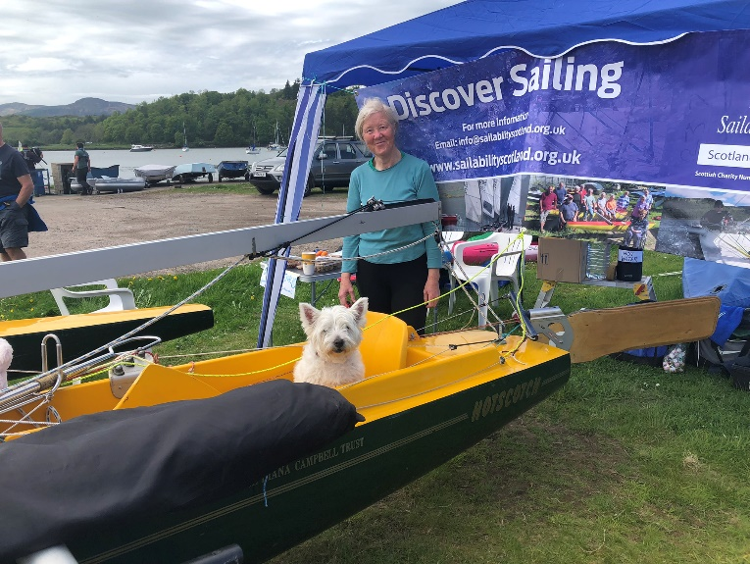
In the middle of May this year Sailability Scotland SCIO were invited to hold a stand at the open day of the Solway Yacht Club at Kippford
We promoted the charity and supplied free drinks and cakes to the visitors, Im not sure if it was the Tea or the cakes or my dog Ruby posing in the Challenger but we did get a bit of free publicity and some interest – also £3.50 in donations!
Also, in May a gentleman by the name of Scot Greenlees sent us a donation of £176.05 Thankyou.
Also, in May I was contacted by the Scout Adventure centre at Lochgoilhead with an offer of a double challenger they had no use for. After some enquiries It turned out to be in excellent condition and of the cantilever top deck variety. So, on 11th May I drove the 310 miles (a journey that took 6.5 hours) to collect the trailer – which came complete with two launch trailers! New tyres were needed so I took some with me and some work needs doing before being used again, but it is certainly a blessing to have had it gifted.
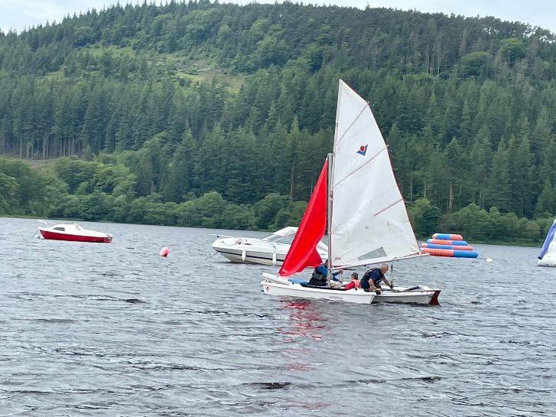
Talking about “gifted” You will recall that the I was contacted late last year with an offer of a “Virus Plus 16” Trimaran that had been stood at the side of Kinloch Rannoch for several years. I travelled the 410 miles (there and back) which took more than 8 hours driving and an overnight stay to collect the boat. Since then, I have had a pair of trampolines made, (which entailed a journey to Port Edgar some 260 miles and 5 hours driving there and back) and spent many hours cleaning sanding, sealing and varnishing, waxing and polishing as well as doing gelcoat and epoxy resin repairs to this boat until it was finally ready to be put on the water for the 1st time on the 16th June. Unfortunately, it was a bit of a disaster as just 200 yards from the shore one of the new trampolines completely failed. However, they continued to sail for about 20 minutes, the boat handled well.
I chose to assess the boat at my local disabled sailors club at Loch Ken, when it has completed its trials and If I then consider it a suitable boat for Sailability Scotland SCIO I will ask the Committee what use they think it would be best put to.
So, I have now had a completely new set of (much stronger) trampolines made (done F.O.C.) by Sail Doctor of Port Edgar. (Another 260 mile round trip).
While I was there they also repaired the mainsail for “Great Scot” (237).
As I have reported previously, another trailer and boat were offered earlier this year by the club at Staunton Harold Reservoir in Derbyshire. This was a 500-mile round trip and entailed an overnight stay, unfortunately the trailer broke down after 30 mile so adding 60 mile to the trip and all to no avail.

Travelling Expenses
So, not counting the trips to 6 regatta venues where I have/will have, towed the double trailer to enable two sailors to sail, this year I have covered 1800 mile and had to stay over two nights all on behalf of the charity – consider it my donation.

Boat Maintenance
The pace of work is picking up now that I am more mobile after my injury in February. “Happy Days 11” is now about to get her top deck repainted. Work on her has required removing several layers of paint and old anti foul from her hull and repainting and new decals fixed, I have had a split mast repaired, mended the broken mast well, mended the smashed prow, the supply and fitted two stainless steel “cleat mounting” wings. Also, the re-sited the tiller and then added a fairlead and block to guide the mainsheet. The sanding and revarnishing of the rudder and centreboard (which also required extensive epoxy resin repair work). Plus all new sheets. She will look like new! Then just two more challengers to bring back to life.

Finally
I know it is only just August but in approximately 8-month time I will be stepping down at our next AGM after 4 years as a trustee. It is imperative for the charity to survive that we attract more members and people willing to step up and become trustees, can I ask everyone to engage with as many people as possible and invite them onboard!

Steve Laycock
Chairman
Sailability Scotland SCIO

