**SAILING INSTRUCTIONS**

**1 RULES**

The Open Meeting will be governed by the rules as defined in the Racing Rules of Sailing (RRS) 2025 – 2028,

the prescriptions of the RYA, the appropriate Class Rules and these Sailing Instructions. Where conflict

occurs, these Sailing Instructions shall take precedence.

**2 NOTICES TO COMPETITORS**

Notices to competitors will be posted on the official notice board located in the Village Hall and the entrance

hall of the Club to the left of the Event Office door.

**3 CHANGES TO SAILING INSTRUCTIONS**

Any change to the sailing instructions will be posted before 08.30 on the day it will take effect, except that any

change to the schedule of races will be posted by 2000 on the day before it will take effect.

**4 SIGNALS MADE ASHORE**

**4.1** Signals made ashore at the pierhead will be displayed at on the flag pole at the landward end of the

pontoons.

**4.2** When flag AP is displayed ashore at the pierhead, “1 minute” is replaced with “not less than 30 minutes”

before the race warning signal.

**5 SCHEDULE OF RACES**

|  |  |  |  |  |  |
| --- | --- | --- | --- | --- | --- |
| Day | Date | Briefing | Time (BST) | Warning Signal | HW (BST) |
| Saturday | 10th May 2025 | 08.30 | 09.45 | 1st Race | 11.15 |
| Sunday | 11th May 2025 | 09.20 | 10.20 | 1st Race | 11.50 |

The Sunday Briefing will be a very short one held at the Pierhead for competitors planning to sail that day.

The warning signal for a second and subsequent race will be made as soon as is practicable after the

conclusion of the previous race. To alert boats that a second race will begin soon, an orange flag will be

displayed for at least 3 minutes before a warning signal is displayed.

**6 CLASS FLAGS**

The Class flags will be:

Challengers - Flag V (Red diagonal cross on White background).

Club HC1 - Flag D (Yellow/Blue/Yellow horizontally).

Club HC2 - Flag T (Red/White/Blue vertically)

**7 RACING AREA**

Appendix A shows the location of the racing area.

**8 THE COURSES**

**8.1** Courses will be set within the race area identified in Appendix A and displayed at the Starting Hut or on the

Committee Boat with a red background indicating that a mark is to be rounded to port and green to starboard.

**8.2** Legs of the course will not be changed after the preparatory signal. This changes RRS rule 33.

**8.3** Boats must pass through the Starting Line at the start of each round of the course.

**9 MARKS**

Marks consist of SYC fixed and movable orange, yellow or red mark buoys. The approximate positions of the SYC fixed

buoys are shown on the SYC Course Chart at Appendix A. Waterproof copies of this chart will be available at

Registration and the Briefing.

**10 AREAS THAT ARE OBSTRUCTIONS**

The locations of these obstructions are shown in Appendix A.

**10.1 Rough Island:** Rough Island must not be passed on its eastern side.

**10.2 Rough Island (Spring Stones Reef):** Boats should at all times pass to the south of Spring Stones Reef at

the southern end of Rough Island. The Reef will be marked by a temporary buoy which will be described

at the Briefing, and if so, this must be passed on its southern side.

**10.3 Nets:** There are 3 stakes in line at the northern end of the Almorness peninsula that are covered at high water. The

outermost one is 12-15m from the shore. Boats are advised to keep clear.

**11 THE START**

**11.1** Races will be started by using rule 26 with the warning signal made 5 minutes before the starting signal.

**11.2**  The Start Line at the Start Hut will be either:

a) A transit from the flagpole in front of the Start Hut and the inner distance mark, which is a perch located in the river in front of the Start Hut. An outer distance mark may be laid but this does not form part of the Start Line except that boats must start between the inner and outer distance marks.

b) When a blue board with a white diagonal stripe is displayed, the start line will be between the mast and the outer distance mark. Although not necessarily close to the line, the perch in front of the Start Hut will act as an inner distance mark.

**11.3** Alternatively, if a Committee Boat is used the Starting Line will be between the pole flying an Orange

Flag on the Committee Boat, and an outer distance mark flying an Orange Flag. An inner distance mark

may be laid adjacent to the Committee Boat and boats shall not pass between this mark and the

Committee Boat. An inner distance mark may be laid adjacent to the Committee Boat and boats shall not

pass between this mark and the Committee Boat.

**12 THE FINISH**

**12.1** After approximately 60 minutes of racing, the finish will be either (a) or (b) as follows:

a) The Finish Line will be the same as the Starting Line. The Starting Hut or the Committee Boat will

fly flag S. Two sound signals will be made as the leading boat passes the last mark.

b) Flag S may be flown from a support boat positioned adjacent to a mark of the course. The race

will finish between that mark and the support boat which will be positioned so that crossing this

Finishing Line allows the mark to be rounded on the required hand. Two sound signals will be given

as the leading boat approaches.

**12.2** Boats must cross the Finishing Line in the direction of the course from the last mark.

**12.3** A boat that has finished is asked to then pass completely through the Finish Line and not to thereafter again

cross the Finishing Line from either direction while other boats are still competing in the race.

**13 PENALTY SYSTEM**

**13.1** RRS Rule 44 is modified from a Two-Turns Penalty to a One-Turn Penalty for a breach of Part 2 while

racing.

**13.2** RRS Rule 41 is modified so that safety boats and support boats may assist a competitor for any reason

other than added propulsion.

**14 TIME LIMITS AND TARGET TIMES**

**14.1** If no boat has passed the first mark within 20 minutes the Race Officer has the discretion to abandon that

race. If he does so, there will be no grounds for redress.

**14.2** There will be no target time for races and no time limit for boats finishing after the first boat has finished

but in order to minimise excessive delays between races, the Race Officer may award a finishing position,

irrespective of their position on the course, to boats that are still racing after the first boat has finished. The

Race Officer’s decision is final and will not provide grounds for a competitor to seek redress. This changes

RRS rule 62.

**15 PROTESTS AND REQUESTS FOR REDRESS**

**15.1** When a protest is lodged, a boat may at the same time request RYA Arbitration as described in RRS

Appendix T, or the Protest Committee or Race Committee may offer it.

**15.2** If the parties and a member of the Protest or Race Committee agree that RYA Arbitration is suitable, an

Arbitrator (who may be that member of the Protest Committee) will call an Arbitration Hearing. When it is

the Arbitrator’s opinion that a boat that is a party to the Arbitration hearing has broken a rule, the party

will be invited to accept a time penalty decided by the Arbitrator and, if accepted, the protesting boat will

be allowed to withdraw the protest in accordance with RRS Rule 63.2(a).

**15.3** When there is not agreement to use RYA Arbitration, or when, after RYA Arbitration, a protest is not

withdrawn, or a time penalty is not appropriate for the facts, there will be a normal protest hearing at

which the Arbitrator may be a member of the Protest Committee. Rules 63.7 and 70 (reopening and

appeal, respectively) do not apply to an Arbitration since this is not a Protest Committee decision or

procedure. A boat may still retire or accept the time penalty, unless retiral or time penalty are not

applicable to the facts, at any time before the start of a protest hearing and receive its protection from

further penalty.

**15.4** The protest (or request for RYA Arbitration) time limit is 30 minutes after the last boat comes ashore.

Protest forms will be available from the Race Office. If there has been no RYA Arbitration, they must be

delivered there within the appropriate time limit. If there has been Arbitration with the decision that

protest hearing is still required, the Protest Form must be delivered to the Race Office within 30 minutes of

the end of the Arbitration. At the discretion of the Protest Committee Chairman, these time limits may be

extended if there are extenuating circumstances.

**15.5** Notices will be posted no later than 30 minutes of the protest time limit to inform competitors of hearings

hearings in which they are parties or named as witnesses. It shall be the responsibility of competitors to

check the notice board for such notices.

**15.6** If a protest committee awards average points for a series, it shall be for the whole series, not races sailed so

, far.

**15.7** Notices of protests by the Race Committee or Protest Committee will be posted to inform boats and will

comply with clauses 15.4 and 15.5 above.

**16 SCORING**

**16.1** The low point scoring system described in RRS Appendix A4 will apply.

**16.2** 2 races are required to be completed to constitute a series.

**16.3** There will be 1 discard if 4 races are sailed.

**17 SAFETY REGULATIONS**

**17.1** If at the Briefing it is announced that a Check-Out and Check-In system will be used:

Each helm (and buddy) will be required to collect a tally from the shore control point located at the top of the pier before they launch and return them as they come ashore. Failure to collect or return a tally without good reason may result in a score of DNC.

**17.2** A boat that retires from a race shall notify the race committee either directly or via a support boat as soon

as possible.

**17.3** Personal floatation of an "International Standard Approved Type" will be worn at all times when afloat, on

the pontoons and on the slipway by both helm and buddy.

**17.4** Each Challenger must have a grab line of free specification fitted toeach sponsonand a dedicated tow line

or painter of at least 8m in length and having a suitable diameter that is led back to the cockpit.

**18 REPLACEMENT OF CREW OR EQUIPMENT AND CREW POSITION**

**18.1** Substitution of competitors buddies will not be allowed without prior approval of the race committee.

**18.2** Substitution of damaged or lost equipment will not be allowed unless authorized by the Race Committee

or Race Officer. Requests for substitution shall be made at the first reasonable opportunity.

**18.3** The helm and buddy should remain seated in their normal positions within the main hull or on a buddy

seat or similar except temporarily in an emergency. This modifies RRS rule 49.

**19 EQUIPMENT AND MEASUREMENT CHECKS**

It is expected that boats entering will comply with Challenger Association Class rules and the SYC and

Challenger Class Association reserve the right to carry out equipment and measurement checks to confirm

that this is the case.

**20 SUPPORT BOATS**

Support boats shall not be permitted other than those designated by Solway Yacht Club.

**21 RADIO COMMUNICATION**

Except in an emergency, a boat shall neither make radio transmissions while racing nor receive radio

communications not available to all boats. This restriction also applies to mobile telephones and other

communication devices.

**22 LAUNCHING AND RECOVERY**

The Launching Ramp and Pier Pontoons are likely to be busy with other fleets wishing to launch and

recover at the same time as the Challenger fleet and the instructions of the Piermaster should be complied

with.

**23 DISCLAIMER OF LIABILITY**

Competitors participate in the regatta entirely at their own risk. See RRS Rule 3, Decision to Race. The

organizing authority will not accept any liability for material damage or personal injury or death sustained

in conjunction with or prior to, during, or after the event.

Sailing is by its nature an unpredictable sport and therefore inherently involves an element of risk. By taking

part in the event, each competitor agrees and acknowledges that:

1. They are aware of the inherent element of risk involved in the sport and accept responsibility for

the exposure of themselves, their crew and their boat to such inherent risk whilst taking part in the event.

1. They are responsible for the safety of themselves, their crew, their boat and their other property

whether afloat or ashore.

1. They accept responsibility for any injury, damage or loss to the extent caused by their own actions or omissions.

d) Their boat is in good order, equipped to sail in the event and they are fit to participate.

e) The provision of a race management team, support boats and other officials and volunteers by

the event organiser does not relieve them of their own responsibilities.

1. The provision of support boat cover is limited to such assistance, particularly in extreme weather conditions, as can be practically provided in the circumstances.
2. It is their responsibility to familiarise themselves with any risks specific to this venue or this event drawn to their attention in these SIs or at the Briefing, which they should attend.

**24 INSURANCE**

Each participating boat shall be insured with valid third-party liability insurance with a minimum cover of

£3,000,000 per incident or the equivalent.

**Appendix A**

**Inner Racing Area**

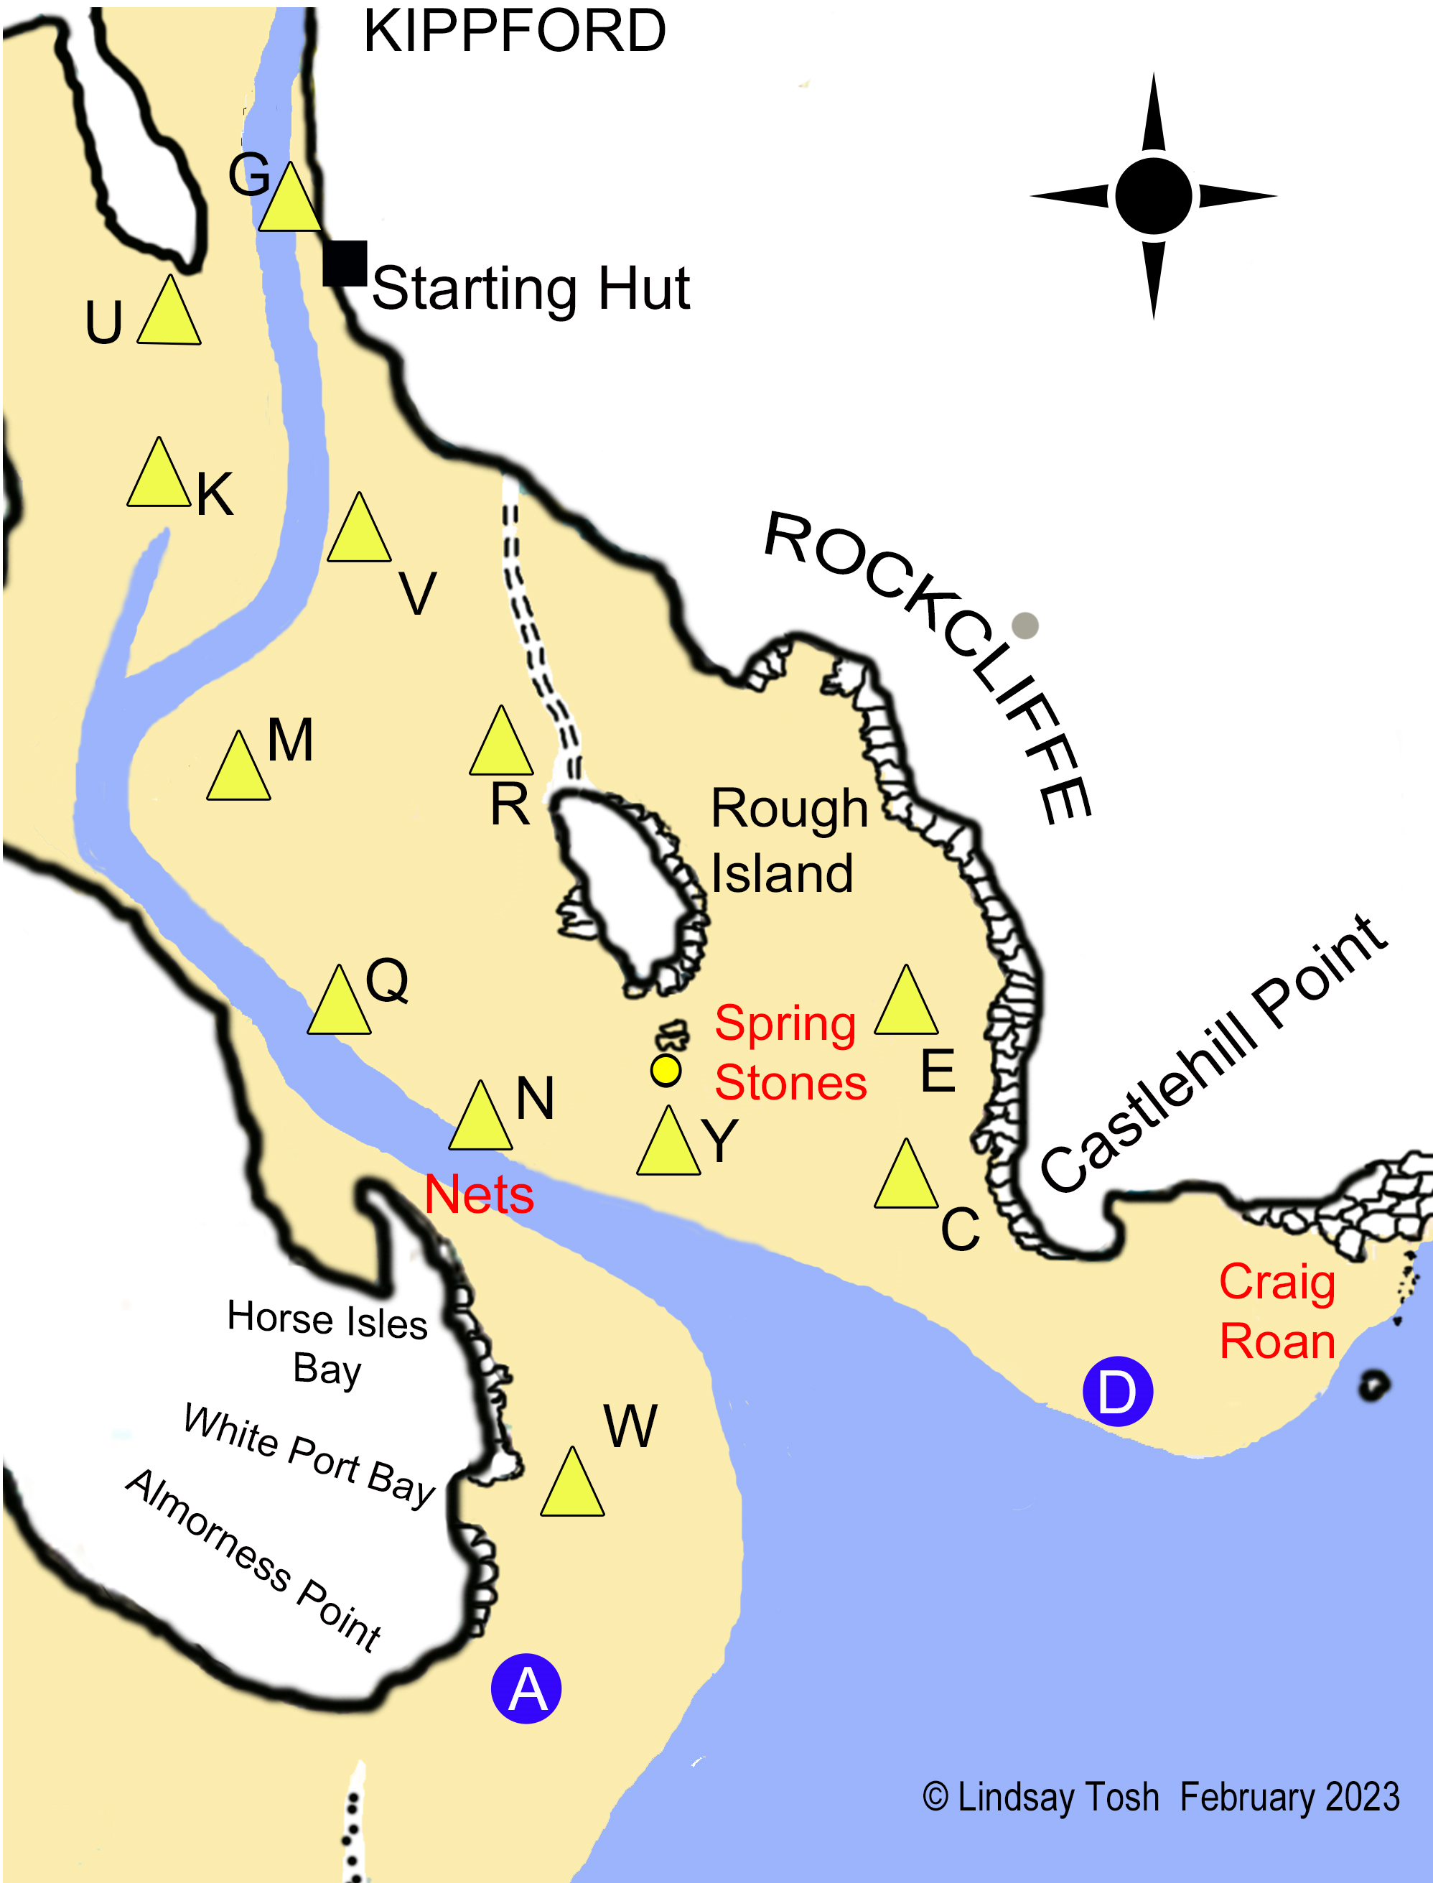

**Note:** The main channel now runs SW from G, past K, instead of taking the curved route shown above.

**Appendix B**

**Notes**

(These Notes do not form part of the formal Sailing Instructions)

To ensure the event goes smoothly, please read below and follow its content over this weekend. Getting the boats launched and “towed or rafted” to and from the racing area (if the wind conditions are unfavourable) and recovered ashore will be vital for the enjoyment of all concerned, for good racing and safe recovery of boats ashore.

1. Vehicles should be moved to car park as soon as unloading is complete.
2. When ready to launch, boats should be lined up on the tarmac roadway leading to the slipway, stern first.
3. Support RIBs and “tow boats” should be launched on Friday and berthed overnight on the pontoon or be launched via the public slipway on the Saturday.
4. Before competitors launch, the helm / buddy should be wearing their tally wristbands ifrequred. See SI 17.1.
5. After launching the trailer should be recovered and returned to its berth.
6. Assuming towing/rafting to the race area is required and once on the west facing arm of the jetty, the boats must be secured but be ready to be picked up by the “tow boat“, who will issue instructions as how they will proceed. (They may choose to tow “daisy chain style” or alongside and may take more than one boat at a time).